Argentina joins TMclass, Peru joins DesignClass

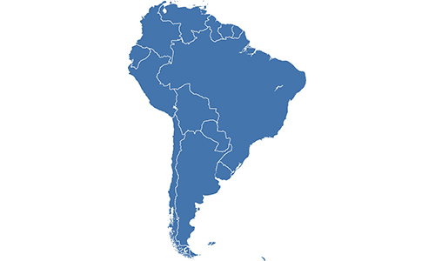

As of 04 November 2019, the [National Institute of Industrial Property of Argentina](https://www.argentina.gob.ar/inpi) (INPI) joined [TMclass](http://euipo.europa.eu/ec2), and will use and accept the list of terms from the harmonised database (HDB) within the tool.

In addition, the [National Institute for the Defense of Free Competition and the Protection of Intellectual Property of Peru](https://indecopi.gob.pe/inicio) (INDECOPI) has joined [DesignClass](http://euipo.europa.eu/designclass) and will use and accept the list of terms from the harmonised database of product indications (HDBPI).

Both become the seventh non-EU offices to use the harmonised databases for trade mark and design terms. There are now 76 IP offices participating in TMclass and 32 in DesignClass.

TMclass offers users the opportunity to search and translate goods and services to and from any of the 44 languages available. In DesignClass users can search and translate product indications in 27 languages.

The adoption of HDB by INPI, as well as INDECOPI’s acceptance of HDBPI, are a deliverable of the [IP Key Latin America programme](https://ipkey.eu/es), directed by the European Commission and executed by the EUIPO.